44-542 Object Oriented Programming
Interfaces

- Study the following diagram and be sure you understand the relationships between all classes and interfaces. This drawing was done in Visio which indicates abstract classes by using italics. In this drawing, AbstractStudent is the only abstract class. An abstract class does not have to include the word Abstract in its name, but it is okay to do so.

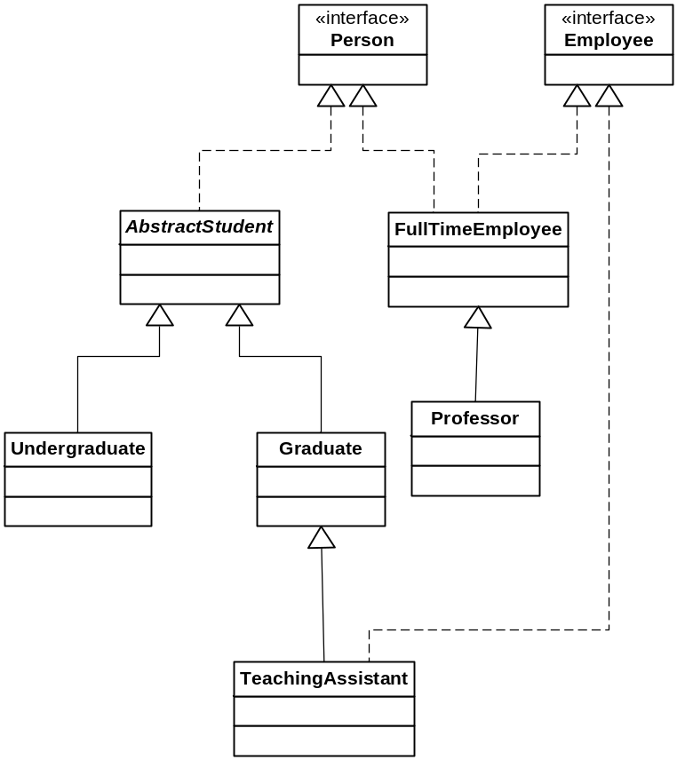

- For each pair of classes or interfaces given below tell which one extends or implements the other. I have supplied the answer for the first pair.
  - Person, AbstractStudent
AbstractStudent implements Person
  - Undergraduate, AbstractStudent
  - Graduate, TeachingAssistant
  - Employee, TeachingAssistant
  - Professor, FullTimeEmployee
  - Employee, FullTimeEmployee
  - FullTimeEmployee, Person

- True or False?
  - A Person is an Employee True False
  - An AbstractStudent is a Person True False
  - An Employee is a TeachingAssistant True False
  - A TeachingAssistant is an Employee True False
  - A TeachingAssistant is a Graduate True False
  - An AbstractStudent is a Graduate True False
  - An Undergraduate is an AbstractStudent True False
  - A TeachingAssistant is a Person True False
  - A Professor is a FullTimeEmployee True False
  - A Professor is an Employee True False
  - A Graduate is a TeachingAssistant True False
  - A FullTimeEmployee is a Person True False
- Which of the following statements are legal? If a statement is illegal, explain why.
TeachingAssistant TA1 = new TeachingAssistant();
Graduate grad1 = new Graduate();
grad1 = TA1;
TA1 = grad1;
- Is the following statement legal? If a statement is illegal, explain why.
TeachingAssistant TA1 = new Graduate();
- Is the following statement legal? If a statement is illegal, explain why.
Graduate grad1 = new TeachingAssistant();

